**Aim:** To predict maintenance requirement of vehicle in advance before it breakdown.

**Background:** Maintenance is a challenging task. System availability and minimize repair resource consumption with maintaining the quality of product is one of the biggest challenge in automotive industry.

Predictive maintenance involves collecting and evaluating data from vehicle to increase efficiency and optimize maintenance processes. It helps in monitoring condition of components and more precisely predict about need of maintenance work.

**Types of maintenance:**

1. Reactive
2. Proactive
   1. Preventive
   2. Predictive

Below picture explain about advantage of Predictive Maintenance over other types.

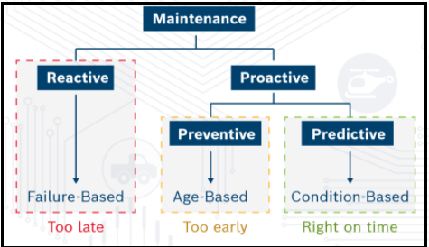

(Image Courtesy: Bosch White Paper-Prognosis for Connected Cars)

**Advantage**:

1. Lower maintenance costs by predicting maintenance activity before component failure
2. Save huge resources by reducing the need to purchase new parts before it fail
3. Reduce out-of-service time by determining when maintenance must be completed in order to minimize system failure risk
4. Helps manufacturers to increase customer satisfaction
5. Reduction in vehicle maintenance cost for end users and warranty cost optimization for the OEMs
6. Reduction in fuel cost and thus reduced vehicle emissions contributing to a cleaner environment.

**How Predictive Diagnosis Works**:

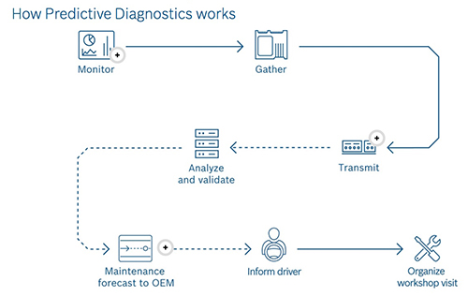

(Image Courtesy: Google Image)

**Approach for further proceeding:**

Approach 1: Use data from sensors

Approach 2: Use historical maintenance and Geographic Information System (GIS) data

Dataset:

1. **Turbofan Engine Degradation Simulation Data Set**

<https://ti.arc.nasa.gov/tech/dash/groups/pcoe/prognostic-data-repository/>

Reference:

1. <https://www.infoq.com/articles/machine-learning-techniques-predictive-maintenance/>
2. <https://github.com/roshanmadhushanka/PythonML/>

**Data Description:**

Data is from NASA open source repository. C-MAPSS (Commercial Modular Aero Propulsion System Simulation) tool was used for simulating a realistic large commercial turbofan engine.

Data is collected with 3 atmospheric operation conditions by using 21 sensors.

**Operations:**

1. Altitudes ranging from sea level to 40,000 ft,
2. Mach numbers from 0 to 0.90, and
3. Sea-level temperatures from –60 to 103 °F.

Mach number (M or Ma) is a dimensionless quantity in fluid dynamics representing the ratio of flow velocity past a boundary to the local speed of sound.

M = u/c,

Where:

M is the local Mach number,

u is the local flow velocity with respect to the boundaries (either internal, such as an object immersed in the flow, or external, like a channel), and

c is the speed of sound in the medium, which in air varies with the square root of the thermodynamic temperature.

**Sensor Data:**

|  |  |  |  |
| --- | --- | --- | --- |
| **Symbol** | **Description** | **Description** | **Unit** |
| T2 | Sensor 1 | Total temperature at fan inlet | °R |
| T24 | Sensor 2 | Total temperature at LPC outlet | °R |
| T30 | Sensor 3 | Total temperature at HPC outlet | °R |
| T50 | Sensor 4 | Total temperature at LPT outlet | °R |
| P2 | Sensor 5 | Pressure at fan inlet | psia |
| P15 | Sensor 6 | Total pressure in bypass-duct | psia |
| P30 | Sensor 7 | Total pressure at HPC outlet | psia |
| Nf | Sensor 8 | Physical fan speed | rpm |
| Nc | Sensor 9 | Physical core speed | rpm |
| epr | Sensor 10 | Engine pressure ratio (P50/P2) | -- |
| Ps30 | Sensor 11 | Static pressure at HPC outlet | psia |
| phi | Sensor 12 | Ratio of fuel flow to Ps30 | pps/psi |
| NRf | Sensor 13 | Corrected fan speed | rpm |
| NRc | Sensor 14 | Corrected core speed | rpm |
| BPR | Sensor 15 | Bypass Ratio | -- |
| farB | Sensor 16 | Burner fuel-air ratio | -- |
| htBleed | Sensor 17 | Bleed Enthalpy | -- |
| Nf_dmd | Sensor 18 | Demanded fan speed | rpm |
| PCNfR_dmd | Sensor 19 | Demanded corrected fan speed | rpm |
| W31 | Sensor 20 | HPT coolant bleed | lbm/s |
| W32 | Sensor 21 | LPT coolant bleed | lbm/s |

**Sensor data Unit details:**

°R : Rankine scales

K = °C + 273.15, °R = °F + 459.67, and °R = 1.8 K. Zero in both the Kelvin and Rankine scales is at absolute zero.

PSIA : pounds per square inch absolute.

rpm: revolution per minutes

lbm/s: Pound Mass Per Second

pps: pulse per second

Phi:Ratio of Fuel Flow to Static Pressure (Ps30)